SOCIAL MEDIA
 | Short | Longer | Imagery
Save The Date | Let’s Accelerate to Zero #23GTSE  The @gtse is taking place this August 22 – 24th, 2023. Join us at the region’s premier transportation event. Our 20% discount gets you front and center in the action to powerful information and engaging networking.  Save the date! | The @gtse is taking place this August 22 – 24th, 2023. Join us at the region’s premier transportation event. Our 20% discount gets you front and center in the action to powerful information and engaging Networking.  This year, GTSE will take its focus to a new level--investigating clean vehicle technology and taking advantage of funding opportunities at the local, state, and national levels. Technology providers in the electrification, hydrogen and alternative fuel industries will bring their knowledge to discuss with fleet practitioners how move forward.  Sign up today! | 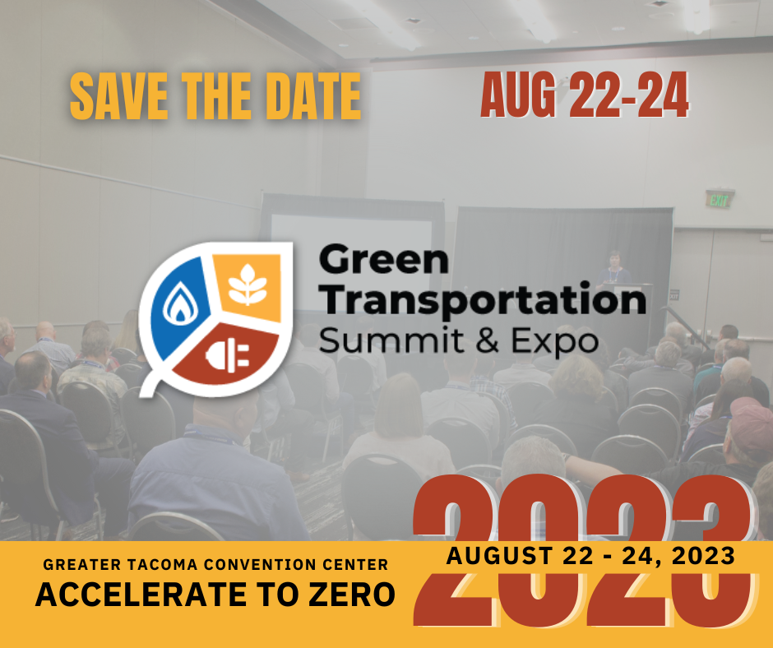
Join Us @ GTSE | As community partners of the #23GTSE, we can’t wait to see you at #23GTSE this year.  #GTSE23 has “can’t miss” networking opportunities that mix with influencers and decision makers in the fleet, clean transportation and sustainability industries.  Join us at #23GTSE! | As community partners of the #23GTSE, we can’t wait to see you at #23GTSE this year.  #GTSE23 has “can’t miss” networking opportunities that mix with influencers and decision makers in the fleet, clean transportation and sustainability industries.  Check out the online program for must-attend sessions. | 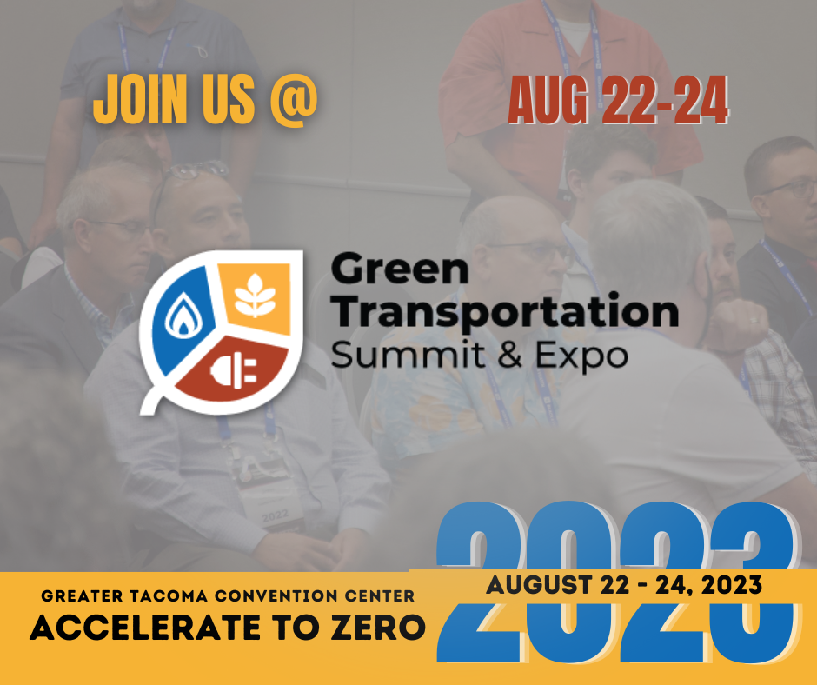
Countdown to GTSE | The countdown begins for #23GTSE. GTSE offers engaging and useful content for every attendee in the #fleet, #transportation, #equity, #engineering, #industry, and #policy sectors.  Use our discount code to get a ticket 20% off. | The countdown begins for #23GTSE. GTSE offers engaging and useful content for every attendee in the #fleet, #transportation, #equity, #engineering, #industry, and #policy sectors.  From high voltage fleet technician training to sessions exploring the intersection of zero-emission vehicles and racial equity, GTSE offers engaging and useful content for every attendee.  The 2023 show will also bring back the highly praised Performance Ride and- Drive event, giving everyone the chance to experience firsthand what clean transportation looks and feels like. | 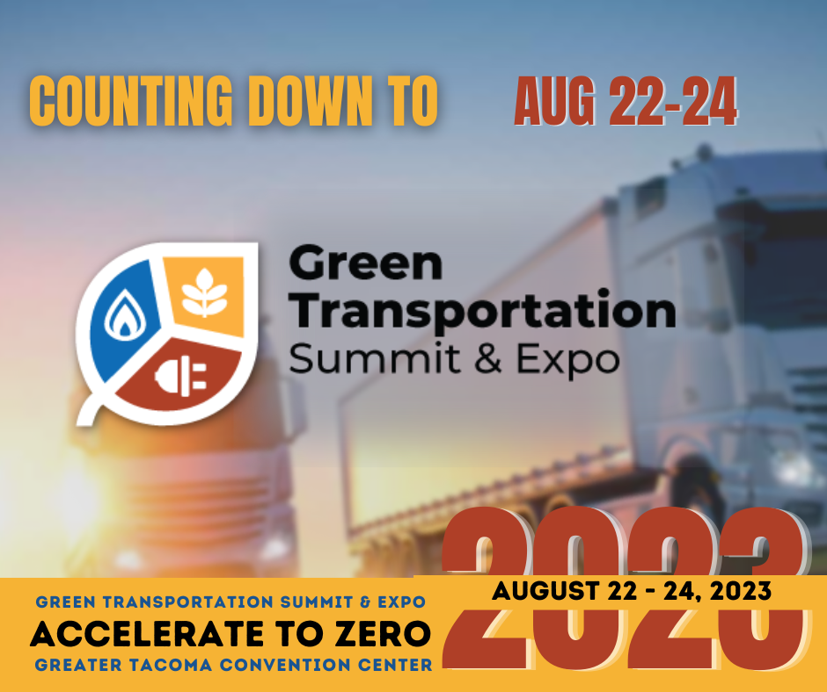

EMAIL MARKETING MATERIALS
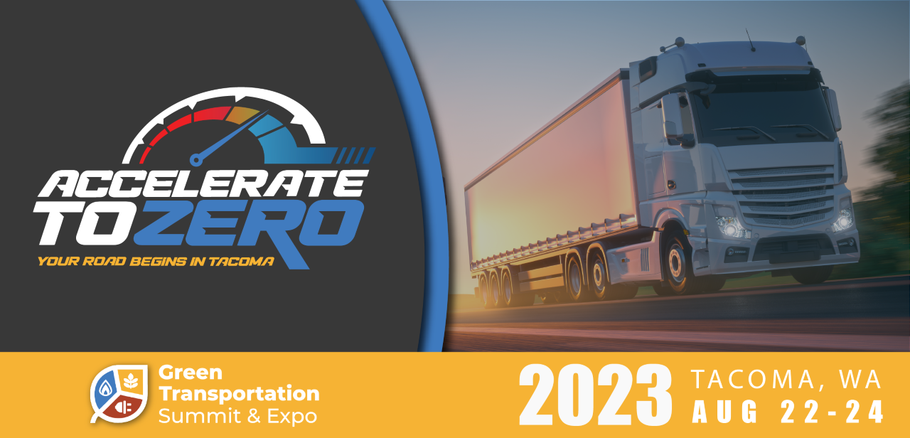
**graphic + photos from dropbox

We can’t wait to attend the Green Transportation Summit and Expo (GTSE) this year!
The region’s leading transportation conference takes place on August 22 – 24, 2023 at the Greater Tacoma Convention Center. The conference is comprised of three days of
- Networking
- Information sessions
- Workshops
- Vehicle Walk-throughs
- Great Accommodation
Check out more details at gtsummitexpo.com. Sign up by July 30th with code “--” to receive a discount to the event.

